# FAST RATES FOR SVM

Rahul ReddyMuppidi-IIT2018103

Lokesh Naik- IIT2018104

A Pratyush-IIT2018124

Mallampalli Maheswarnath-IIT2018137

Gowni Sai Pavan-IIT2018139

B Tech(IT)-6th sem,IIIT Allahabad

**Introduction**

The assignment is about understanding the algorithm behind Fast rates for Support Vector Machines(SVMs). We have run the algorithm of Fast SVM against two different data sets and compare the results alongside other standard classifiers.

1. **Explanation**

In recent years support vector machines (SVMs) have been the subject of many theoretical considerations. Despite this effort, their learning performance on restricted classes of distributions is still widely unknown. In particular, it is unknown under which nontrivial circumstances SVMs can guarantee fast learning rates.

“Kernel” is a set of mathematical functions used in the Support Vector Machine that provides the window to manipulate the data. So, Kernel Function generally transforms the training set of data so that a non-linear decision surface is able to transformed to a linear equation in a higher number of dimension spaces.

Quality of a classifier is measured by classification risk



The smallest achievable risk is called the Bayes risk of P and a function attaining this risk is called a Bayes decision function and is denoted by fp. Obviously, a good classifier should at least produce decision functions whose risks converge to the Bayes risk for all distributions.

Our aim is to give SVMs a better theoretical foundation by establishing fast learning rates for a wide class of distributions. To this end we propose a geometric noise assumption.This assumption is then used to determine the approximation properties of Gaussian kernels which are used in the SVMs we consider. Provided that the tuning param-eters are optimally chosen our main result then shows that the resulting learning rates for these classifiers can be as fast as n-1.

1. **Results**

We are using MCC for comparing results.

The Matthews correlation coefficient (**MCC**) or phi coefficient is used in **machine learning** as a measure of the quality of binary (two-class) classifications.

We can calculate the MCC from confusion matrix by using below formula



Results compared in below table after using data sets[2] and [3]

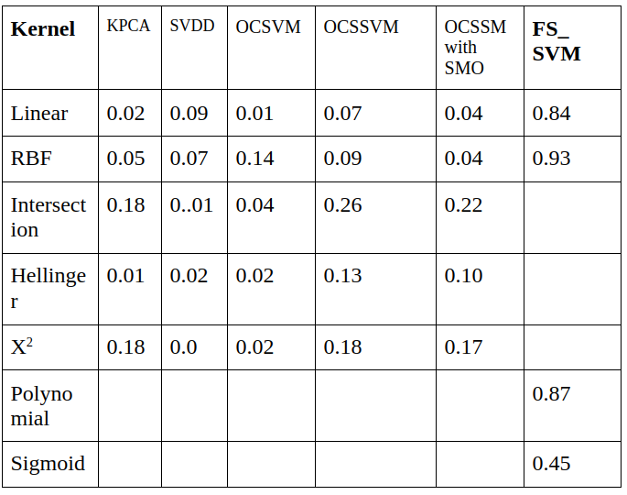

fig(1)

1. **Conclusion**

As we can see along with speed there is strong improvemednt in performance.If we use cross validation and fine tune hyper params accuracy and mcc can be further improved.

**References**

[1]-Fast rates for Support Vector Machines using Gaussian Kernels- Ingo Stenevart and Clint Scovel

[2]-<https://archive.ics.uci.edu/ml/datasets/Letter+Recognition>

[3]- <http://host.robots.ox.ac.uk/pascal/VOC/voc2012/>